

Grade 10



INFORMATION TECHNOLOGY
JUNE EXAMINATION – 2013
GRADE 10
Paper 2

MARKS : 120
TIME : 2 hours
EXAMINER : A.P. Baboolall / Z.B.B. Mohammed
MODERATOR : A. Ebrahim

This question paper consists of Nine questions on 8 pages.
Answer each SECTION on a new page.

SECTION A [40]

QUESTION ONE – MULTIPLE CHOICE
Choose the best answer (A – D) for every question.
Write down only the question number and the correct letter e.g. 1.0 C

1.1 An example of both an input and an output device.
A. Touch pad B. Touch screen
C. Scanner D. Keyboard

1.2 Is the key on a keyboard most commonly associated with help functions.
A. SysRq B. HELP
C. F1 D. TAB

1.3 Is NOT a component of the CPU.
A Control Unit B Arithmetic Logic Unit
C Registers D The control bus

1.4 Is not a typical function of an operating system.
A. Virus detection B. Memory management
C. Resource allocation D. Control of peripheral devices

1.5 This refers to the illegal installation, copying and distribution of proprietary software.
A. Software piracy B. Hacking
C. Shareware D. Plagiarism

1.6 The term “default printer” means:
A. The printer has a fault B. The printer that printing will be sent to
C. The drivers have not been installed D. The fault on the printer has been fixed

1.7 This term does not logically belong with the others.
A. Keyboard B. Search Engine
C. Monitor D. Memory

1.8 The typical capacity of the storage devices in arranged in descending order.
A. Hard drive, CD, DVD, flash disk B. DVD, hard drive, flash disk, stiffy disk C. CD, hard drive, DVD, flash disk D. Hard drive, DVD, CD, stiffy disk

1.9 Which statement concerning memory and storage is false.
A. Memory needs constant power if it is to retain its contents.
B. Because RAM is electronic, it is much faster than storage which is mechanical.
C. You need much more RAM than storage on a PC.
D. Data is stored optically or magnetically on storage devices.
1.10 Memory that keeps its information even if the power is switched off.
A. RAM B. EDO RAM
C. ROM D. DDR 300 SDRAM [10]

QUESTION TWO – MATCHING [10]

Match Column A with Column B.
Write down only the letter from column B that corresponds with the description column A.
Column A | Column B
2.1 An extension for graphics files. | A | ADSL
2.2 A hardware component manufactured by companies such as Intel, AMD and Motorola. | B | LAPTOP
2.3 The speed of a computer processor is measured in | C | CPU
2.4 A port commonly used to connect hardware ranging from printers to flash disks. | D | BMP
2.5 Outdated electronic and computer equipment that get scrapped | E | DPI
2.6 Is a non-impact printer. | F | FREEWARE
2.7 A unit of measurement of resolution associated with both monitors and printers. | G | WINZIP
2.8 A useful utility program. | H | USB
2.9 Software that is copyrighted but costs nothing. | I | GHZ
2.10 This type of computer is more expensive to repair and almost impossible to upgrade. | J | LASER PRINTER
 | K | E – WASTE
[10]

QUESTION THREE – TRUE/FALSE [10]

State whether the following statements are True or False. If False, correct the statement.
3.1 Piracy includes buying one licence for software and installing it on multiple computers.
3.2 Scratch is a visual programming language used to write a computer program using basic concepts.
3.3 Plug and play refers to the use of computers to play games.
3.4 Utility programs perform system maintenance and administration tasks.
3.5 A computer worm can distribute itself on a hard drive but NOT over a network. [10]

QUESTION 4 – TERMINOLOGY [10]

State the term/ terms that best explains the descriptions below.

4.1 Licence agreement between the software and the user specifying conditions on the
installations and use of the software.
4.2 A precise rule or set of rules specifying how to solve a problem .
4.3 Type of Software made available with licence that allows you to access and modify the source
code, but not to sell the software.
4.4 Special non-volatile chip on the motherboard that holds the instructions needed to start the computer up when it is switched on.
4.5 Software that tries to monitor and track the ways you use your computer and sends information
off to third parties without your consent.
[10]

Section B: Hardware and System Software [43]

***Answer this section on a new page***

Read the following scenario and then answer the questions that follow.

Scenario:

You are employed in the IT division of a company called
PC Techtronics & Applications.
This is a small business establishment that is steadily growing.

In addition to you there is a small group of contractors that are assigned the larger projects such as software development that are taken on by the company.

QUESTION FIVE: COMPUTER ARCHITECTURE AND HARDWARE [24]

PC Techtronics & Applications has been given the contract of supplying computers
to a company called MegaAccounts . The management has a choice of two computer packages presented below. The management requires your assistance in deciding which of the packages to choose.
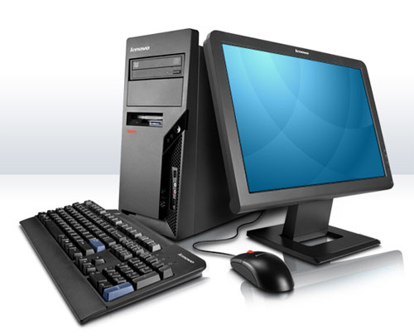 | 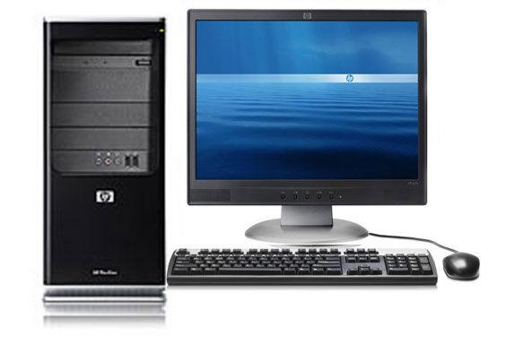
Computer A  Pentium 4 2.8 GHz  180 GB HDD  512 MB RAM  19” LCD colour monitor  DVD/CD-writer combo drive  4 * USB Ports  MS Windows XP Home  Optical mouse  MS-Office 2003  Free Lexmark ink-jet printer  Ergonomically designed QWERTY keyboard  Free digital camera | Computer B  AMD 3.02 GHz  80 GB HDD  1 GB RAM  21” CRT colour monitor  DVD writer  4 * USB Ports  MS-Office 2007 (1 month Trial)  HP laser printer  Infra-red mouse  56 K fax modem  Bluetooth keyboard  Free 512 MB flash disk

5.1 The management is concerned about the types of monitors available.
5.1.1 What do these acronyms stand for?
5.1.1.1 LCD 1
5.1.1.2 CRT 1
5.1.2 Why is LCD a better option for a monitor? 1

5.2 Computer A or B has a pre-installed Operating System. Name the Operating System as stated. 1

5.3 Which computer has more RAM? What is the advantage of having more RAM? 2

5.4 The management heard about the term ROM and wants to know what it is. Explain to
the management what ROM is by explaining the difference between RAM and ROM. 2

5.5 What function does the MODEM serve in Computer B? 1

5.6 The management prefers a laser printer over the inkjet printer supplied with Computer A.
Explain the difference between an inkjet and a laser printer. 2

5.7 Briefly explain why the optical mouse is better than the track ball mouse. 2

5.8 The MS-Office 2007 (Computer B) would not work after 1 month.
What must MegaAccounts do to rectify the problem. 2

5.9 Computer A comes with an ergonomically designed keyboard and Computer B uses Bluetooth.
Explain to the management:

5.9.1 What is “ergonomics”? 2
5.9.2 How does the Bluetooth technology Keyboard differ from ordinary keyboards.
State an ergonomic advantage of the Bluetooth keyboard. 2

5.10 Computer A comes with a Pentium 4 2.8 GHz.
5.10.1 What do Pentium and AMD refer to? 1
5.10.2 Which company manufactures the Pentium? 1
5.10.3 What is the latest technology available now that performs this function? 1

5.11 Explain the difference between the 2 DVD drives available in Computers A and B. 1

5.12 Both systems come with many USB ports.
Why are USB ports necessary for present times? 1

[24]

QUESTION SIX: OPERATING SYSTEM AND SYSTEM SOFTWARE [19]

You need to explain certain software concepts to your staff and the client companies, so that they can buy the software that they need for their business.

6.1 Software is divided into two categories, i.e. Application Software and System Software.
Define :
6.1.1 Application software
6.1.2 System software 4

6.2 From the advertisement in Question 5 - Computer A, provide an example of:
    - System software 1
6.2.2 Application software 1

6.3 What are the THREE main functions of any OS? 6

6.4 Give an example of an Open Source Software OS. 1
6.5 Anita, an employee at PC Techtronics & Applications is having problems with the new
printer that she has just connected to her computer. When asked whether she has loaded
the driver for the device, she stated that it is a new printer and that she doesn’t have to.
Explain to Anita, the purpose of a driver. 2

6.6 State the difference between plug & play and hot swappable. 4
[19]

SECTION C - Programming and Software Development [26]

QUESTION SEVEN: PROGRAMMING AND SOFTWARE DEVELOPMENT [16]

Scenario:
PC Techtronics & Applications is rapidly expanding. Mr Keshav employs 2 temporary workers.
Their gross weekly wage for the week is determined by multiplying the hours worked by an hourly rate.
A tax of 12% is deducted if the gross weekly wage is R 1000 or more and 8% if it is less
than R 1000. Each employee’s net wage is calculated by subtracting the tax deductions from the gross income.

7.1 Draw a flowchart to determine and output the net weekly wage of a single employee.
(Hint: Write an algorithm first) 8

7.2 Examine the Algorithm below and answer the questions set
Note : Line numbers are not part of the algorithm code

Line 1 | s ← 0
Line 2 | a ← 0
Line 3 | Loop counter from 1 to 5
Line 4 | Start loop
Line 5 | Input number
Line 6 | a ← s + number
Line 7 | End loop
Line 8 | a ← s / 5
Line 9 | Output s
Line 10 | Output a

7.2.1 Using the Algorithm above, copy and complete the Tracetable below,
using the following Sample Input number values as, and if, needed.
4 3 9 8 13 3
Step No | Line No | counter | number | s | a | Output
1
2
3
4
5
6
7
8
9
10

6
7.2.2 What is the above Algorithm aiming to achieve? 2
[16]

QUESTION EIGHT – DATA REPRESENTATION AND STORAGE [10]
8.1 What is the difference between data and information 2
8.2 Which number system is used internally by computers? 1
8.3 Convert the following numbers into the number system specified:
(Show all steps for the calculations.)
8.3.1 The binary number 110 1111₂ into decimal. 3
8.3.2 The decimal number 1466₁₀ into hexadecimal. 4
[10]

SECTION D: INTEGRATED SCENARIO [11]

QUESTION NINE: Social Implications

9.1 Mr Keshav is anxious about the employees spending prolonged periods of time in front
of the computers as he has heard that computers can have an adverse effect on their health.

9.1.1 List THREE ways in which computers can possibly contribute to ill health. 3
9.1.2 List TWO common-sense, practical precautions that you could take to prevent
your health being adversely affected by the prolonged use of a computer 2
9.2 PC Techtronics & Applications is concerned about the large amounts of paper usage
and the environmental impact caused by the increased computer usage.
9.2.1 Discuss TWO ways of saving paper. 2
9.2.2 State 2 ways on how users can contribute to green computing, to save
the environment. 2

9.3 What does Digital Divide refer to? Explain. 2
[11]
TOTAL = 120

